GRADE 7 ACCELERATED · UNIT 1 · LESSON 3  Solving Two-Step Equations  Additional Practice 7A.01.03 | Name_________________________  Date__________________________  Period________________________

1. Match each property of equality to the example that shows it. Write the letter of the example on the line.
Every example below starts from 4 + 5 = 9.
Property of Equality | Letter
Division Property of Equality
Subtraction Property of Equality
Multiplication Property of Equality
Symmetric Property of Equality
Addition Property of Equality

A. | 4 + 5 − 7 = 9 − 7
B. | (4 + 5) ÷ 7 = 9 ÷ 7
C. | 9 = 4 + 5
D. | (4 + 5) × 7 = 9 × 7
E. | 4 + 5 + 7 = 9 + 7

Use the equation 33t − 99 = 0 for questions 2 through 5.
2. Complete the sentence to describe the equation.
The variable t is first being __________________ by 33, and then 99 is being __________________ from this product. The value of the expression 33t − 99 is __________________ to 0.

3. Describe the operation that isolates 33t on the left side.

4. Describe the operation that isolates t on the left side.

5. Now solve 33t − 99 = 0. Then check your solution by substitution.

For questions 6 through 11, solve the equation and check your solution by substitution.

 | 6. | −4 + |  | = 16

7. 12n + 9 = 93

8. 6x − 12 = 48

9. 5y + 7 = 47

 | 10. |  | − 8 = 17

 | 11. | 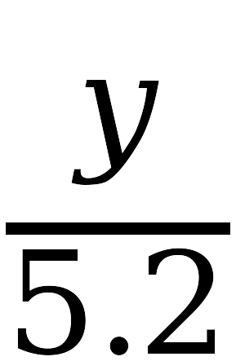 | + 3.4 = 4.3

